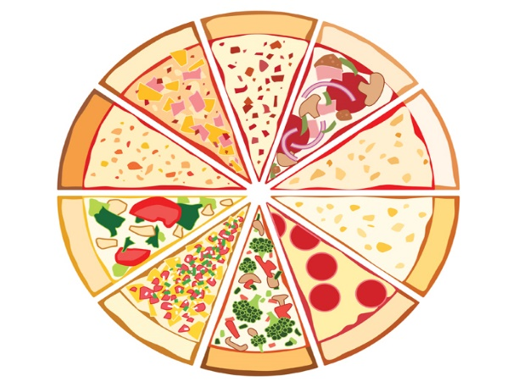
Pizza Party &
Parent Information Night
Thursday, March 15, 2018
For Central Manor
3rd, 4th, 5th, 6th Graders
and their families!
Childcare will be provided by our Title I Aides for children younger than our third graders.

Where? Central Manor Elementary School’s Cafeteria. Come in through the side doors!
When: Doors open at 5:45 p.m. for our PIZZA Party
At 6:15 p.m.
- Breakout sessions begin at for parents and their intermediate-age students.
- Snacks will be provided during the second break-out session.

Parent/s, Guardian/s and Intermediate Students:
Plan to join us for an exciting night exploring ways to help your Central Manor student/s
continue to progress in his/her academic career.
We will be exploring topics in math, reading, spelling & writing and study skills.
Please complete the registration form below and return it to the office by Friday, March 9, 2018 so that we may have materials ready for you to take home! If you already registered, no need to re-register. We hope to see you on the 15th! Please keep the top half of this paper as your reminder for the date and time of this event. Thank you!

First and Last Name/s of Adults Interested in Attending

Children possibly attending: (include all children that will be attending – no matter what age they are)
Name | Grade/Teacher | Age

Parent/Guardian Signature ___________________________________ Date: ___________________

