Parents,  Once you have sent me your e-mail address, I will send you a link to accept into our “Class.” The platform allows me to share your child’s daily behavior, share pictures, and send messages to you. You can choose to operate this through a webpage or download the app!  We’ll always be in communication!  Check out my school blog right before the start of our year to see what will be offered on the 1st day of school! I will also send a message through ClassDojo.  Lunch for the First Day |  |  | 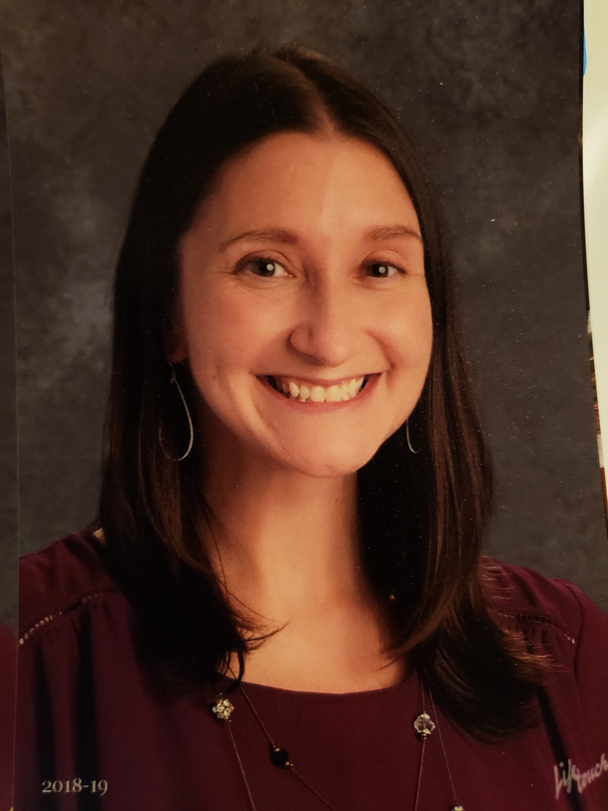  All About Mrs. Davis!  Hello! My name is Mrs. Davis. This is my 13th year teaching, but only my 2nd year with first graders! First grade is the BEST and I feel so lucky to teach here at Martic. I earned my degree in Elementary Education from Indiana University of Pennsylvania, and I am currently working toward my master’s degree in language and literacy at Millersville University. I LOVE learning and my goal is to teach the kids to be life-long learners too!  I was raised in Erie, PA by my loving grandparents. We spent a lot of time lakeside, boating or just relaxing and enjoying the beach. I moved to Lancaster with my husband after college. I live with my husband, Mr. Davis, our two cats, Meerkat and Clark, and our fun-loving dog, Bandit. In the summertime I can usually be found running with Bandit or with my nose in a book! My husband and I love being outdoors with family and friends, canoeing on the Conestoga River or cooking s’mores over a campfire! We love spending time with our family and friends!  I am excited to see all my new first graders on the first day of school, Thursday, August 21st!  Love, Mrs. Davis  Welcome to first grade!  [Address]  [City, ST ZIP Code] |  |  | Parents! Please send me your e-mail to my e-mail address listed above. I will send you an invite link to my ClassDojo page. This is how I plan to communicate important messages, daily behavior, and class updates/pictures throughout the school year.  Mrs. Davis  First Grade  Martic Elementary  284-4128 (3413)  http://blogs.pennmanor.net/adavis  Email: amanda.davis@pennmanor.net
Dear First Grader,  YOU are officially a FIRST GRADER!! YAY! I am so excited to be your first grade teacher and get to know you! We are going to learn so much! As you start to prepare for school, try to begin to get yourself in a school routine by getting a good night sleep and eating a healthy breakfast to start the day. Remember to keep reading over the summer or have a story read to you. We will be doing lots of reading in first grade! You will also be a mathematician and learn how to add, subtract, tell time, problem solve, and more. We will also be plant scientists, learn about our community, and so much more! Get ready to write lots of stories, poetry, and non-fiction. It’s going to be a great school year! Have fun this summer and I will see you before you know it!  Love, Mrs. Davis |  |  | Parents: Very Important  First Day Information:  Please remember to have your child wear the enclosed name tag on the first day of school. This will help me get to know your child’s name as we get adjusted to the first week of school. Please also write your child’s bus number on the back of the name tag so teachers and school helpers can help them get on the correct bus at dismissal time. Thank you!  Parents, please take the time to fill out the survey and send it in with your child on the 1st day of school!  Summer Reading Incentive:  Please review the packet included to learn more about the Martic Summer Reading Incentive! |  |  | Below is a list of the school supplies needed for the first day of school. Also make sure your child has a backpack. Please know that supplies will need to be replenished throughout the year in your child’s tool box.  - Tool Box  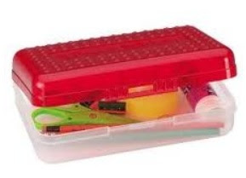  - Sharpened Pencils  - Crayons (16 or 24 pack)  - Scissors  - 8-10 Glue Sticks and replace through the year!

