    Parents,  This platform allows me to share your child’s daily behavior, share pictures, and send messages to you. You can choose to operate this through a webpage or download the app! Once you have sent me your e-mail address, I will send you a link to accept into our “Class.”  We’ll always be in communication!  Check out my school blog right before the start of our year to see what will be offered on the 1st day of school! I will also send a message through ClassDojo.  Lunch for the First Day |  |  | 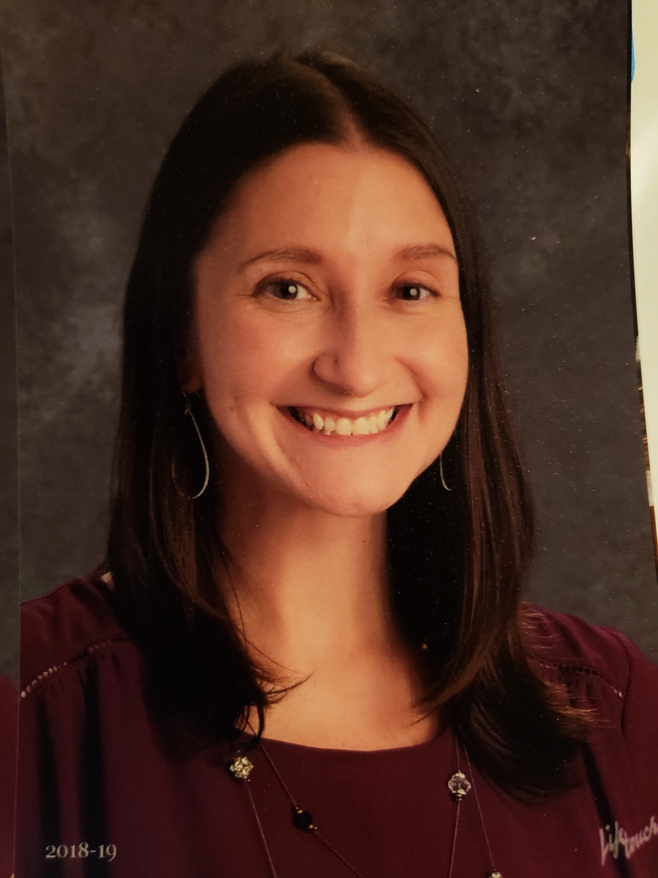  All About Mrs. Davis!  Hello! My name is Mrs. Davis. This is my 14th year teaching. I have taught first grade at Martic for the past two years, however all my other years of experience were in fourth grade. Fourth grade is the BEST and I feel so lucky to teach here at Martic. I earned my degree in Elementary Education from Indiana University of Pennsylvania, and I am currently working toward my master’s degree in Language & Literacy at Millersville University. I LOVE learning and my goal is to teach the kids to be life-long learners too!  I was raised in Erie, PA by my loving grandparents. We spent a lot of time lakeside, relaxing and enjoying the beach. I moved to Lancaster with my husband after college. I live with my husband, Mr. Davis, our two cats, Meerkat and Clark, and our fun-loving dog, Bandit. In the summertime I can usually be found running with Bandit or with my nose in a book! My husband and I love being outdoors with family and friends, canoeing on the Conestoga River or cooking s’mores over a campfire!  I am excited to get to know all of you and look forward to seeing you all on your first day of school!  Love,  Mrs. Davis  Welcome to first grade!  [Address]  [City, ST ZIP Code] |  |  |   I will be sending you an invite link to my ClassDojo page. This is how I plan to communicate important messages, daily behavior, and class updates/pictures throughout the school year.  Mrs. Davis  Fourth Grade  Martic Elementary  284-4128 (extension 2105)  http://blogs.pennmanor.net/adavis  Email: amanda.davis@pennmanor.net

  Dear Fourth Grader,  YOU are officially a FOURTH GRADER!! YAY! I am so excited to be your fourth grade teacher and get to know you! As you start to prepare for school, try to begin to get yourself in a school routine by getting a good night sleep and eating a healthy breakfast to start the day. I hope you have continued to read over the summer, as this year you get to use all those great reading skills to really analyze and think about the texts you read. I can’t wait to find out what genres interest you the most! You will be a mathematician this year, using multiplication, division, problem solving skills, and much more. Get ready to learn all about the great state of Pennsylvania and how our local government runs. I know that you will enjoy exploring ecosystems, matter, magnets, and our solar system. We will use writing as a way to share our thoughts and analyze and interpret our readings. School this year will be different, but one thing that will not change is our ability to learn TOGETHER as a team! We are going to have a GREAT year, I just know it!  Love, Mrs. Davis |  |  | 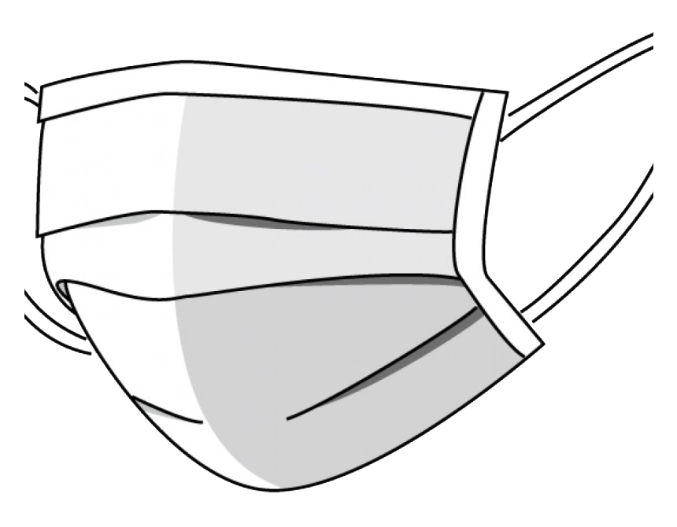  Parents: Very Important  First Day Information:  Please check your child’s group assignment (A or B) to make sure you know your child’s blended learning weekly schedule. If you have questions or concerns, please call the school office. Also, don’t forget to have your child wear a mask to school!  Parents, please take the time to review this pamphlet. I also have a special OPTIONAL assignment just for you!    Summer Reading Incentive 2020: Your child received a Read Through the Alphabet form in their report card envelope, and it was also posted on the Martic blog. |  |  | Below is a list of the suggested school supplies. (We will provide the materials if you are unable to get them)      - Writing Utensils and Pencil Sharpener (with cover)    - Headphones or Earbuds  - Scissors    - Two Composition books  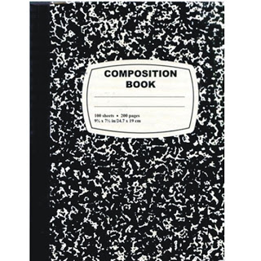    - Six Pocket Folders (the cheap ones) – one of each color: red, orange, yellow, green, blue, and purple

