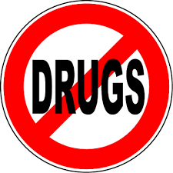
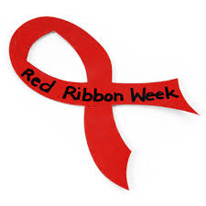
Red Ribbon Week
October 25th to 29th

10/25 – Monday: Wear Red. Wear red to show you are “RED-Y” to stand up for healthy choices.
10/26 - Tuesday: Keep it mellow. Say NO to drugs and wear your PJ’s to school.
10/27 - Wednesday: Camo Day – Be bold and brave by making healthy choices. We can’t hide our Penn Manor pride. Wear camouflage.
10/28 - Thursday: Be a “Jean-ious” – Don’t do
DRUGS. Wear Jeans.
10/29 – Friday: Team up Against Drugs. Wear your favorite team jersey, shirt or colors!

