Bravery Quotes to Ponder
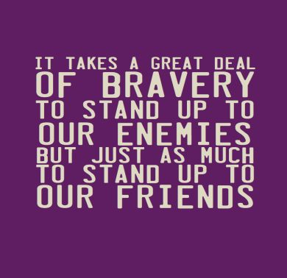

“Can a man still be brave if he's afraid?"
'That is the only time a man can be brave,' his father told him.”
― George R.R. Martin, A Game of Thrones

“It is curious that physical courage should be so common in the world and moral courage so rare.”
― Mark Twain

“And one has to understand that braveness is not the absence of fear but rather the strength to keep on going forward despite the fear.”
― Paulo Coelho

“It is hard to be brave, when you're only a Very Small Animal.”
― A.A. Milne, Winnie-the-Pooh

“Many of the bravest never are known, and get no praise. [But]that does not lessen their beauty...”
― Louisa May Alcott

