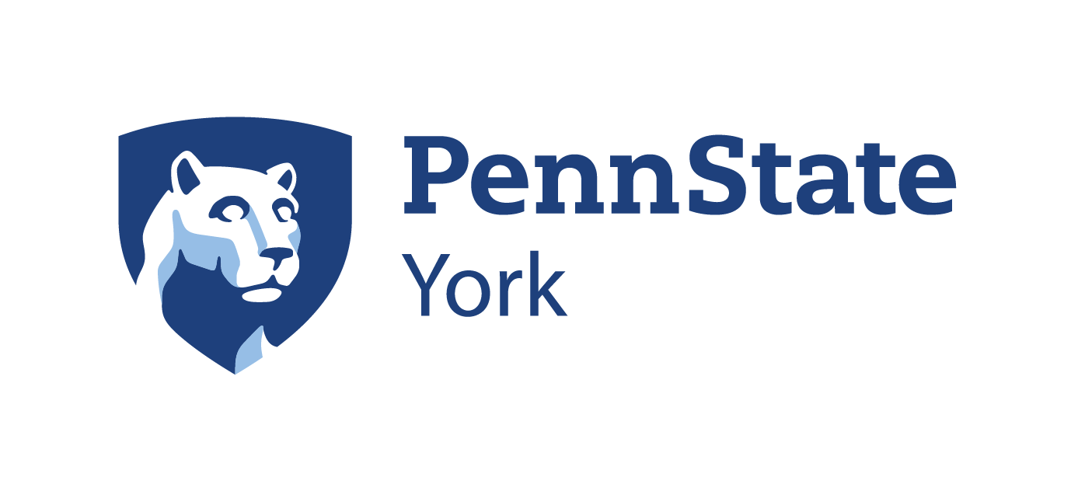

Scholastic Aptitude Test (SAT) Preparation
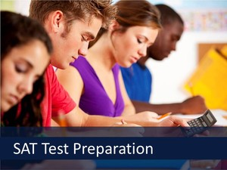

Verbal and Math Prep
Penn State York
Saturdays
September 29 -October 20, 2018
8:30a.m. – 12:30p.m.
- Course provides a review of important English/verbal and math skills assessed in the SAT I.
- Students learn valuable test-taking strategies and become familiar with test format.
- Course fee: $210.00 includes the latest version of the book “The Official SAT Study Guide” from the College Board.
Program Administrator: Erin Nelsen, Continuing Education Associate, Penn State York
Phone: 717-771-4197
Email: ekn5@psu.edu
Penn State is an equal opportunity, affirmative action employer, and is committed to providing employment opportunities to all qualified applicants without regard to race, color, religion, age, sex, sexual orientation, gender identity, national origin, disability or protected veteran status. U.ED. YKO 18-41
The Pennsylvania State University encourages qualified persons with disabilities to participate in its programs and activities. If you anticipate needing any type of accommodation or have questions about the physical access provided, please contact Erin Nelsen at 717-771-4197 in advance of your participation or visit.

