Blurb to be included on a website or in a newsletter or email blast.

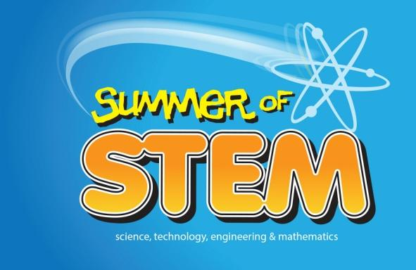

STEM….Science, Technology, Engineering and Math
Spend the summer of 2015 with your friends at these Summer of STEM camps. These exciting, interactive camps help prepare young people for the 21st century workplace where the ability to apply science, technology, engineering and math skills creatively is essential. Participating partners include Lancaster County Career and Technology Center, Lancaster Science Factory, Millersville University, Thaddeus Stevens College of Technology, The Common Wheel and the Lancaster YWCA .

For Summer of STEM Camps scholarship information visit http://www.lancastercountywib.com/youth-activities/career-camps . Questions? Contact Hope Schmids at hschmids@lancastercountywib.com or 717.509.5613 x233.

Please consider making announcements or allowing information to be shared at community events, parent nights and assemblies, as well as including in weekly communication folders, progress reports, report cards or any other outreach to your students and parents.

There are over 150 scholarships available across all camps. We want every last dollar to go to deserving kids. Please help us award these scholarships and serve low income youth in our community.

Auxiliary aids and services are available upon request of individuals with disabilities. TTY 717-391-3570 Equal Opportunity Employer/Program

