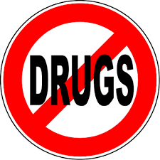
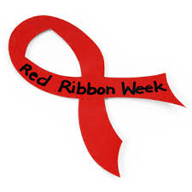
Red Ribbon Week
October 28th to 31st

10/28 - Monday: Team Up Against Drugs. Wear your favorite sports team apparel.
10/29 - Tuesday: Orange you glad you don’t do drugs (wear orange).
10/30 - Wednesday: Support Red Ribbon week (wear red)
10/31 - Thursday: Be a “Jean-ious” – Don’t do
DRUGS. Wear Jeans.

