Dear Parents and Guardians, 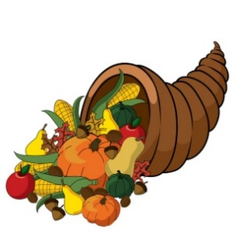

Every year Penn Manor School District assists families in need with Thanksgiving meals. We would like to make this process more uniform across the district. We will be collecting the food listed below between November 4th and Friday, November 15th. If you have a child in one of these grades, please consider donating to help our community.

Kindergarten-boxed mashed potatoes
1st grade-boxed stuffing
2nd grade-canned corn
3rd grade-canned green beans
4th grade-canned sweet potatoes
5th grade-canned cranberry sauce
6th grade-canned gravy (NO GLASS)
7th and 8th-Cornbread or Muffin mix-water based

If your family is able and willing to provide more than is listed above and would like to make a monetary donation, please send the amount you choose by check to your child’s school secretary by November 15th. Make your check payable to Penn Manor Family Fund and on the memo line write “Holiday Food Basket”.

Dear Parents and Guardians,

Every year Penn Manor School District assists families in need with Thanksgiving meals. We would like to make this process more uniform across the district. We will be collecting the food listed below between November 4th and Friday, November 15th. If you have a child in one of these grades, please consider donating to help our community.

Kindergarten-boxed mashed potatoes
1st grade-boxed stuffing
2nd grade-canned corn
3rd grade-canned green beans
4th grade-canned sweet potatoes
5th grade-canned cranberry sauce
6th grade-canned gravy (NO GLASS)
7th and 8th-Cornbread or Muffin mix-water based

If your family is able and willing to provide more than is listed above and would like to make a monetary donation, please send the amount you choose by check to your child’s school secretary by November 15th. Make your check payable to Penn Manor Family Fund and on the memo line write “Holiday Food Basket”.

